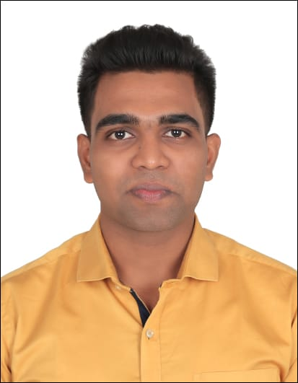
MUKUND MANI GUPTA
mukundmani10@gmail.com
Flat No. 301, Swami Samarth CHS, Plot No. E/1-C, Opp Kendriya Vihar, Sector 12, Kharghar Navi Mumbai, 410210.
+91 7506758328
LINKED IN PROFILE :- https://www.linkedin.com/in/mukund-mani-gupta-92926923b

CAREER OBJECTIVES :- "To build career in a growing Organisation, where I can get the opportunities to prove my abilities by accepting Challenges."

EXPERIENCE :- Fresher

EDUCATION :-

Course | Name of  Institution/University | Year of Passing | Percentage/CGPA
Master of  Commerce in  Accountancy | Pillai College of  Arts, Commerce & Science. | 2024 | Pursuing
Bachelor of Commerce in  Accounting and  Finance | Ramsheth Thakur College of Commerce & Science. | 2021 | 7.07 CGPA
HSC | Ramsheth Thakur College of Commerce & Science. | 2018 | 52.92%
SSC | Siddharth Multipurpose Residential High School. | 2016 | 46.00%

CERTIFICATION COURSES :-

COURSE NAME | PASSED / GRADE
Soft Skills | PASSED
Blockchain In Accountancy | ‘A’
Diploma In Computer Application (DCA) | ‘A’

PROJECT WORK :-
- The study on Banking Services Offered By Nationalized Bank In Kharghar Region.
- A study on Starbucks Marketing Strategy.

SKILLS AND ABILITIES :-

  - Basic Excel
  - Microsoft Word
  - Power point Presentation
  - Brings Strong Work Ethics and Leadership Skill
  - Willing To Learn and Adopt New Opportunities and Challenges
  - Good At Communication Skill
EXTRA CURRICULAR SKILLS :-
- Keeping up the technological advancement
- Running and Playing Football
- Reading Book
PERSONAL DETAILS :-
- Date of birth :- 22th September 2000
- Gender :- Male
- Martial status :- Single
- Language known: - English and Hindi
- Nationality: - Indian

DECLARATION :-

I hereby declare that all the above information is correct to the best of my knowledge and belief.

Date:
Place : Navi-Mumbai (Mukund Mani Gupta)

